**Develop and Edit – Reading Material**

**Overview:**

The goal of a presenter is to remove all barriers between them and their audience so they can share their ideas and expertise with them in the most natural and direct way possible.

**Objectives:**

This reading material is designed to help you:

- Review your Presentation content using appropriate tools

**Introduction:**

It’s more than simply throwing a few slides together and reading a script; even for experienced presenters there are a lot of things to consider each and every time they face an audience.

Develop and Edit

This presentation will go from the rough draft to the final polished version.

Start with the Big Picture

* Is it clear?
* Is it crisp?
* Is it possible to misunderstand?
* Is there something missing?
* Is there something extraneous?
* Are there any sensitive overtones?

Can it be paraphrased or re-written for:

* Better appeal?
* Easier understanding?

**Polish**

* Review the structure
* Concise the points
* Color code if required
* Choose the colors carefully
* Add necessary notations to the images
* Avoid overcrowded/overcrowding
* Make it simple, neat and clearly visible

**The Importance of Structure in Presentations**

**STRUCTURE**

Let's take a look at the three parts that make up the structure of any presentation: Introduction, Body, and Conclusion.

**Introductions**

The introduction of a talk is an opportunity to get your audience interested in your talk as well as prepare them for the journey. You’ll want to use the brief time that you devote to the introduction wisely. Here are some key components of effective introductions:

**Entry point-** What is the best way to begin the talk? Your entry point should cultivate the audience’s interest in your topic so that they will want to pay attention to your upcoming presentation. Often, the entry point can be a chance for you to establish the importance of your topic or provide a “big picture” view of its significance. You might consider sharing a story from your research experience or providing an example. There are many strategies that can be employed, but the important thing to remember is that your entry point should be purposeful and help you begin to get the audience invested in your talk.

**Establish credibility-**Although your credibility will be established in large part from your content, it is a good idea to briefly mention your credentials as they relate to the topic. You might mention who has sponsored your work. Or, you might discuss why are interested in this area and feel it is important. This can take many different forms, but you should consider sharing some information that will increase your credibility with the audience.

**Preview the development of the talk**- Let the audience know the purpose of the talk and how you plan on covering the material. Audiences appreciate hearing a map of the presentation.

**The Body**

Structuring the body of a presentation should begin with giving some critical thought to what your goals are for the presentation and thinking about what type of information will need to be shared in order to accomplish those goals. It is common for presenters to try to do too much in a presentation. Perhaps they try to cram all of the details about one year’s worth of research into a 15 minute talk. Or, as is commonly seen at conferences, they try to pack all of the information from a complex research paper into a short conference presentation. Typically, this type of talk is doomed before it even begins.

You need to carefully consider what is reasonable to cover in the time that you have, and think about the opportunities that presentation venue allows that aren’t possible in a paper. Your presentation will be much more successful if you decide to focus on highlighting a part of the work and giving the audience an excellent understanding and appreciation for that part. If the audience really has a firm grasp on the part that you focus on for the talk, you can then include some discussion about its relevance to the whole of the work, and the result is a much more satisfying presentation for an audience. Few people enjoy a presentation that covers every detail at a breakneck pace (typically while clicking through 40 bullet filled slides). It is hard for even the most sophisticated listener to derive much benefit from that type of presentation. Most can get more from reading the paper. Instead, you should aim higher, and use the opportunity of a presentation to do something that a paper cannot.

To accomplish this, you must begin with thinking about what the main idea is that you want your audience to take away and what the purpose is for your talk, and then select points that will get you to that goal. We can think of these key points as your assertions. It is likely that you will have one main assertion for the whole talk—this is main idea that you want your audience to know/believe as a result of the talk. The rest of the talk will be comprised of sub-assertions—these are the areas that your audience needs to know in order to “arrive” at your main assertion.

As you think about organizing your sub-assertions (e.g. which should come first, second, etc.), you need to consider what your audience needs to know in order to appreciate and understand what will come next. Presenters of technical material will often “jump right in” to very difficult concepts, when in fact the audience might have benefitted from there being a sub-assertion or two that came before and gave them the information that was necessary in order for them to appreciate and understand the upcoming material. We can see this represented visually below via an “assertion tree”.

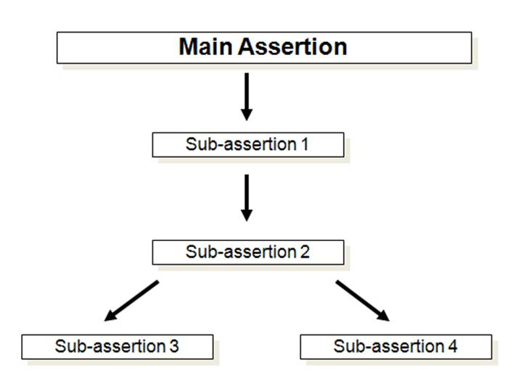

In this example, sub-assertions 1 and 2 build upon one another, that is to say, it is necessary to understand sub-assertion 1 before you can move on to sub-assertion 2. These two sub-assertions serve to provide the information that is necessary for the audience to be prepared for sub-assertions 3 and 4. Sub-assertions 3 and 4 are not necessarily dependent upon one another, hence their parallel placement. But, it is essential to understand sub-assertions 1 and 2 in order to be prepared for sub-assertions 3 and 4.

This is not intended as a recommendation of structure for you next talk, but instead it is to get you to think about what an “assertion tree” might look like for you next presentation. Which ideas are dependent upon one another? What order do they need to be presented in to achieve the maximum comprehension of your audience?

**Conclusion**

The conclusion of a talk is a crucial part of the talk’s structure, yet it is often neglected. Many presenters will just get to the end of all of the planned content and will end rather unceremoniously with “That’s all I have.” Or an abrupt, “Any questions?” With a small amount of effort, a good conclusion can increase retention and add some polish to your talk. You should view your conclusion as your final chance to reinforce what you want you audience to take away from your presentation and reach any audience members that may have drifted off.

There are three goals that you should think about achieving with your conclusion:

**Review-** You should recap the key ideas that you covered in the presentation as a way of brief review for your audience.

**Final appeal-** Tell the audience what you hope your talk has shown them; essentially it is your final reminder of your main assertion.

**End with impact-** You might consider an appropriate final thought for the talk. A well-planned closure line can wrap a presentation up very smoothly. Of course, you should follow up with asking for questions.

**Structure – A demonstration**

**Discussion of the Presentation**

Watch the video--<http://ed.ted.com/on/LgrmyL2G>

**Introduction** (0:00-1:17)

This speaker’s introduction has several strengths that stand out.  The first is that she establishes her credibility as a speaker on this topic well.  She mentions her experience in working at a plant and that she saw firsthand some of the issues with O-Rings.  Secondly, the main assertion for the talk is clear: Silver plated C-Rings should replace O-Rings in nuclear power plants. Another key strength is that she very clearly previews for the audience what the talk with cover: 1) The function of the control rods in a plant, 2) How O-rings are relevant to that function, and 3) Why the silver coated C-Ring is more effective than the O-Ring. This prepares the audience for the information that is coming and provides a glimpse at the speaker’s sub-assertions.

**The Body (1:17-8:15)**

This is how an assertion tree for this talk would look:

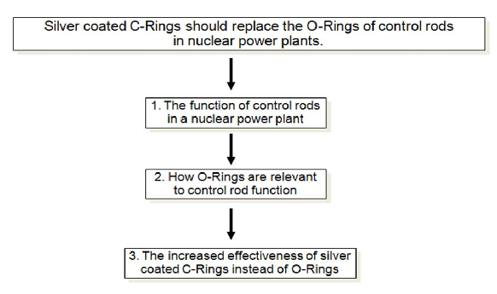

The main structural strength of this presentation is the speaker’s ability to highlight the most important pieces of information that the audience must know in order to understand the main assertion of her talk (Silver-plated C-Rings should replace O-Rings in nuclear power plants).

She chooses her sub-assertions by asking herself what the audience needs to know in order to understand her main assertion.  This is an important technique that presenters of technical material should consider to make their talks more effective. It is often tempting to want to tell the audienceeverything about a topic. As a result, the audience can become buried in details that cause them to lose sight of the main message.

Let’s consider the choices that this speaker made.  She could have decided to explain a nuclear reaction in much more detail and she could have then explained all of the inner mechanics of a Boiling Water Reactor before explaining the control rods. If she had done this, her talk could have very quickly become unfocused.   Instead, this speaker knows that the key idea that the audience must understand in order to support her main assertion is the function of a control rod in a nuclear power plant. Once we have this piece of information, we are then able to understand why it is a concern if the control rods don’t function properly. We are now prepared appreciate the significance of the O-Ring’s impact on the function of a control rod.

Ultimately, each of these sub-assertions gives the audience the ability to understand and appreciate the main assertion of the talk: Silver coated C-Rings should replace O-Rings in nuclear power plants.

**Conclusion** (8:15-9:30)

As this speaker concludes, she provides a reminder of the benefits of the C-Rings over the O-Rings because this is the information that she wants her audience to remember.  Finally, to close the talk, she provides the audience with a look at the “big picture” importance of keeping nuclear power plants functioning well. This is effective because it allows the audience to situate all of the information that they just learned into a more broad perspective. It is easier for an audience to remember information if they understand the broader importance of it. Smaller details can be forgotten, but if those details are woven into a fabric that the audience already has an understanding of, then those details become much more important.

**10 Things You Should Never Do in a PowerPoint Presentation**

PowerPoint is still the most commonly used presentation software on the market. Most of us have turned to PowerPoint when we need to put together a slide deck. As an application, it allows you to do everything you need to do in creating an effective presentation. Unfortunately, it also comes with enough bells and whistles to lead you down the path to presentation hell. No doubt you’ve experienced some painful PowerPoint presentations in your time. If you want to be known as someone who does PowerPoint right, here are 10 things you should never do.

1. Cram a slide with too much detail: This one is obvious. If the people around a table or further back in a room can’t read what’s on your slides, they get frustrated. This is especially true for charts and spreadsheets. It’s safe to assume that copying and pasting Excel spreadsheets into your slides is a bad idea. Use slides to share data highlights and provide details verbally or via a handout. Make sure your text is big enough to read (36pt headlines and 20pt body text at least).
2. Reproduce your whole talk on your slides: If you’re reading your entire presentation from your slides, you have definitely entered PowerPoint hell. Within minutes, everyone will zone out. Someone will ask whether they can get the slides electronically since they contain everything you planned to share. Many people will wonder why you didn’t just email your slides and ask everyone to read them. Aside from making yourself superfluous as a presenter and fomenting rebellion in your audience, you’ll also have way too many slides!
3. Reveal everything at once: One of the most common reasons for not providing printed copies of slides in advance is to prevent people from reading ahead and pre-empting your desired process. A well-crafted presentation has a distinct flow and contains a few deliberate surprises or revelations. You want to share information at your pace. Within each slide you can do this by using various masking, slide-building or animation techniques. The key is to reveal information gradually for greater impact and to keep your audience with you, not ahead of you.
4. Splash on too many colours – or really awful colours: While there may be situations when neon green, electric orange and lavender make sense in a presentation, mostly they don’t. Choose colors that don’t leave a retinal after-image or make the content difficult to read.
5. Jazz it up with cute or funky fonts: Your presentation is meant to support the message you’re communicating, not obscure it. Funky fonts are hard to read. Your safest bet is to use web-friendly, easy-to-read fonts like Arial, Calibri, Tahoma, and Verdana. Use bold sparingly to draw attention (not for every bullet point like this unfortunate example!). And, for the most part, avoid italics.
6. Clutter your slides with a busy background template (or cause confusion with an irrelevant background): You may have a standard presentation template created by your company for use in all presentations. If it was professionally produced, it likely includes low-key branding that doesn’t clutter up your background and provides an unobtrusive palette for good text-color contrast. On the other hand, background templates that change with each slide, include complicated images or patterns, or display themes that have no connection to the content of your presentation are definitely not helpful.
7. Go crazy with the sound effects: Including, for effect, one quotation that types itself onto the screen, accompanied by the clicking of a keyboard, might be entertaining. When every bullet point is ushered in by the same sound effect, teeth will start to grind. The same applies to bells, swooshes, and camera shutter sounds. Even music can become an irritant if used inappropriately. Use sound effects sparingly and only to enhance the meaning of your content.
8. Set embedded videos to autoplay: PowerPoint makes it easy to embed video directly into your presentation. Video is a great way to engage an audience, provide entertainment value or help make a difficult point. If your video starts playing automatically before you’ve had a chance to set the stage, it may lose the intended impact. Also, autoplay doesn’t always kick in right away. When a video stalls, most presenters try to click play, which then advances the slide. Your best bet is to set up the video to be started on a click. That way you retain control and can set up the video and start when you’re ready.
9. Mix and match animations from slide to slide: Too many animations in a presentation will irritate an audience. Different animations from one slide to the next will make them cry for your blood. This is especially true if the animations you select involve a lot of movement; for example, one slide has each bullet point spiral in and the next slide has each bullet point fly in from a different side of the screen. You’re only two slides into your presentation and half of your audience is already suffering from motion sickness! Use animation sparingly and stick with one or two moderate animations in any one presentation.
10. Automate your animations when you haven’t mastered the timing: Finally, don’t let PowerPoint take over your presentation. If you’ve ever done a TED Talk, you’ll know that it can be stressful having your slides advance automatically. In an effort to keep things simple, some people create fully automated presentations with each point entering at a timed interval and slides advancing automatically. That might work if you’ve delivered a presentation twenty times and have the timing down pat, to the second. For most people, panic would set in if something happened to interrupt their flow and the presentation continued without them.

**Conclusion**

Presentations can be an excellent way to share information with a group of people. An effective slide deck can help you stay on track while keeping people interested, engaged and entertained. So, don’t sabotage your message by misusing and abusing the presentation software or by letting it run your show.